Veg & Stout Stew with dumplings

Prep: 20 mins Cook: 1 hr 15 mins Serves 4-6

Ingredients:

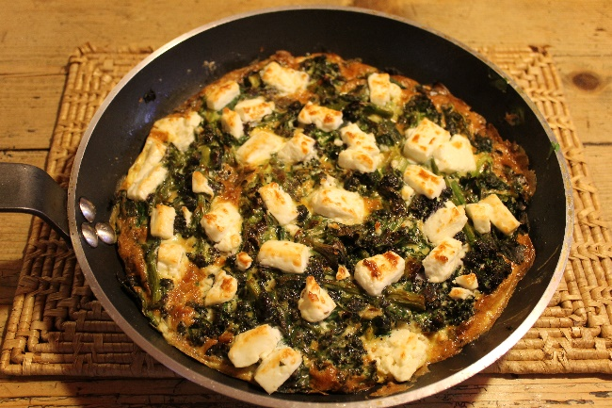
Ingredients:
- 2 tbsp olive oil
- 2 large onions
- 150g chestnut mushrooms, halved
- 1 heaped tbsp plain flour
- 2 carrots, peeled and cut into large chunks
- 2 parsnips, peeled and cut into large chunks
- Swede (about 400g) peeled and cut into large chunks
- Celeriac (about 500g) peeled and cut into large chunks
- 150g pearl barley
- 2 sprigs fresh thyme
- 2 tbsps dark soy sauce
- 2 tbsps tomato puree
- salt and black pepper
- 750 ml vegan stock
- 500 ml vegan stout (beer)
- 100g spinach

For the dumplings:
150g plain flour
1.5 tsp baking powder
75g vegetable suet
tbsp chopped thyme leaves

Heat the oil in a large casserole or lidded pan, add the onions and cook, stirring, on a medium heat for 8 mins until soft and translucent
Add the mushrooms and cook for 5 mins until lightly browned
Stir in the tblsp flour, cook for a minute or so
Add all the root veg, pearl barley, thyme, soy, tomato puree, salt & pepper to taste.
Pour in the stock and stout, bring to a boil, reduce the heat, cover and simmer for 30 mins
Remove the lid and stir gently, cook for 10 mins more until sauce is thickened.

Meanwhile mix all the dumpling ingredients with a pinch of salt and pepper, then mix in 100ml water
Roll the dough into 8 balls
Stir the spinach into the stew and nestle the dumplings on the surface, leaving a little space in between them
Replace the lid and cook for 20 mins, or until the dumplings are puffed up and firm.
Enjoy!

