CARROT SOUP

Cooking time 40mins
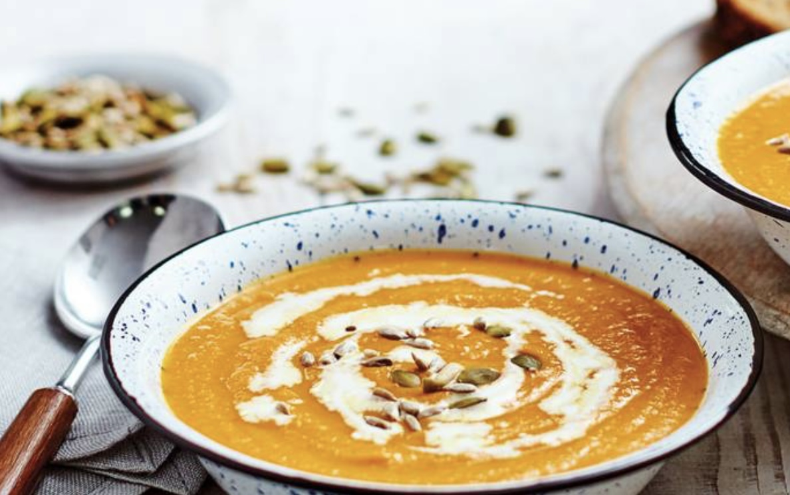
INGREDIENTS:-

1kg carrots, peeled and chopped
1 garlic clove, crushed
10g butter
1tbsp runny honey
1 onion, chopped
1 leek, chopped
2 sticks celery, chopped
1Ltr chicken stock
500ml water
Olive oil
1/2 lemon, juice only
Salt and black pepper

To serve:-

100ml double cream, creme fraiche or yogurt
100g mixed seeds

METHOD:-

- In a frying pan, sauté the carrots and garlic in the butter and a dash of olive oil for 5-10mins until starting to caramelise.

- Add the honey and cook for another 5mins until the carrots are glazed and the pan is nearly dry.

- Sweat the onion, leek and celery until very soft, with a little olive oil in a large saucepan.

- Add chicken stock, water and glazed carrots to the saucepan and simmer for 20mins

- Blend until smooth and season to taste with salt, pepper and the lemon juice before reheating.

6) Serve in bowls swirling in some cream, creme fraiche or yogurt and topping with
Seeds

