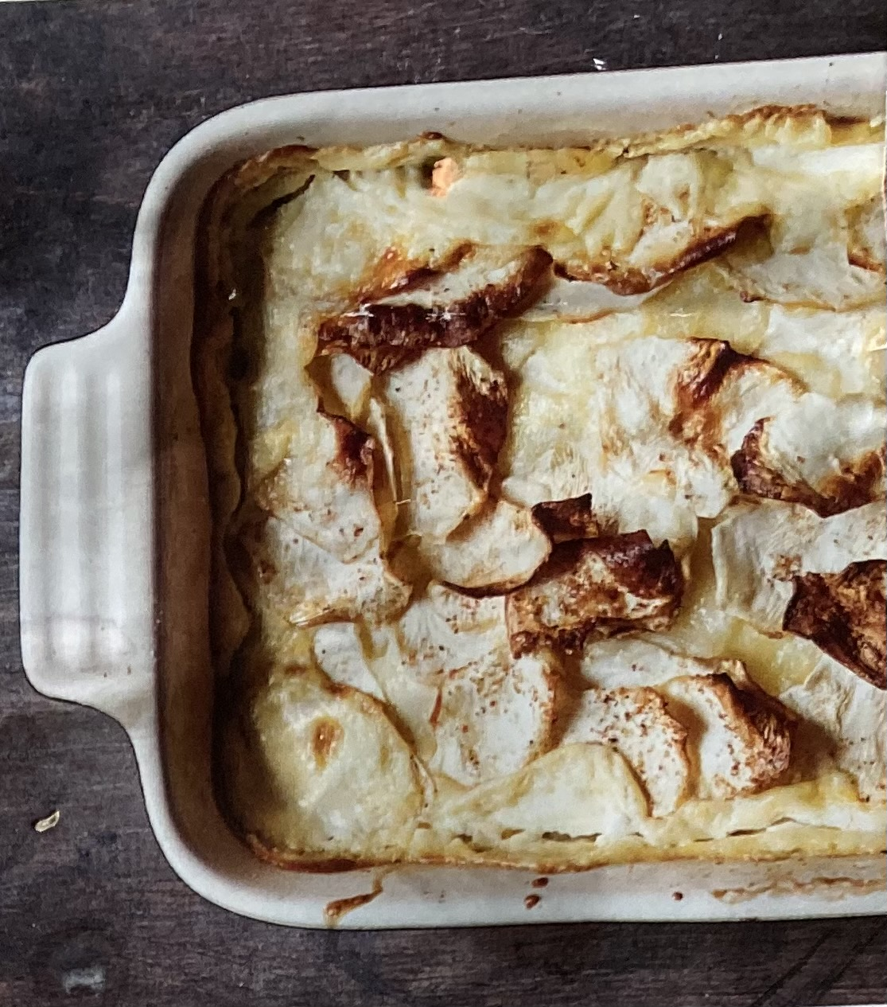
BAKED CELERIAC GRATIN

This can be a main dish or side. Cooking time 45mins at 180`C/350`F/Gas mark 4
30/20cm ovenproof dish.

INGREDIENTS:-

500ml double cream
1 shallot, sliced
1 garlic clove, bashed
1/4 tsp grated nutmeg
1/4 tsp cloves
1/4 tsp black peppercorns
2 bay leaves
1 large celeriac, peeled, halved and sliced 3mm thick
2 large potatoes (not floury ones) peeled and sliced 3mm thick
Sea salt

METHOD:-

- Pour cream into a large pan and add the shallot, garlic, bay and spices. Bring the pan just to the boil then remove from the heat, cover and leave to infuse for 30mins. Strain through a fine sieve.

2) Cover the base of the dish with a thin layer of cream followed by a layer of slightly overlapping
celeriac slices.

3) Drizzle over a little cream, season with salt and add a layer of potato slices.

4) Repeat the layers, pressing them down occasionally, until all the veg is used.

5) Pour over any remaining cream, cover with foil and bake for 20mins.

6) Remove foil and bake for 25mins or until tender to a sharp knife and golden brown.

