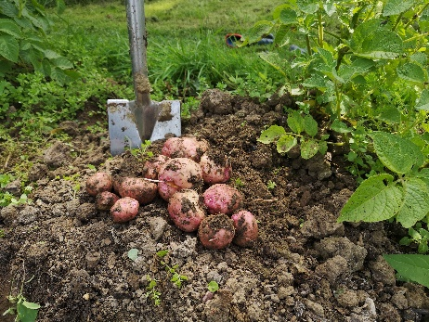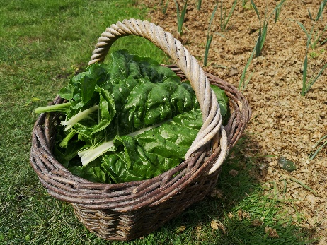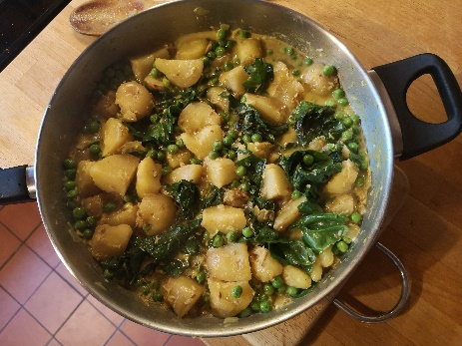

New potato, chard and coconut curry
Serves 4 – thanks to Meera Sodha(The Guardian) for this recipe

Ingredients for the coconut sauce:
- 1 tsp cumin seeds
- 2.5 cm piece root ginger, peeled and grated
- 2 green chillies roughly chopped
- 3 garlic cloves, peeled
- 30g unsweetened dessicated coconut
- 400 ml tin coconut milk

Other ingredients:
- 3 tbsps rapeseed oil
- 1 large onion, peeled, thinly sliced
- 600g new potatoes, cut into chunky bite-sized pieces
- 1.5 tsp garam masala
- .5 tsp turmeric
- 1 tsp salt
- 200g chard or spinach – stems cut into small pieces, leaves shredded
- 250g frozen peas or fresh peas if you have them!

- Put the sauce ingredients into a blender or food processor and blitz into a smooth(ish) mix
- In a large lidded frying pan, heat the oil over a medium heat, fry the onion for 5 mins until translucent. Put in the potatoes and fry for around 10 mins, until they are lightly golden brown and the onions are soft, dark and sticky.
- Stir in the garam masala, turmeric and salt, then add the coconut sauce and bring up to a gentle bubble. *
- Add the chard stalks (and fresh peas if using them) and cook for 5 mins.
- Add the leaves and frozen peas, cover again and simmer for a final 5 mins, until the potatoes are tender and the leaves have wilted.
- Serve with basmati rice or chapatis and a fiery pickle on the side.
- *My top tip – you can add the “sauce” ingredients at this stage without actually making the sauce – it doesn’t seem to make much difference and saves on a bit of washing up!!

